Network Security
IPsec
Angelos Keromytis
Columbia University
Fall 2002

Co je to IPsec
- Soubor protokolů pro zaručení
  - Autentizace původce dat
  - Kontrola integrity dat
  - Zajištění důvěrnosti dat
- Vzhledem k aplikacím transparentní
- Neprůhledný vzhledem k linkové úrovni
- Flexibilita

Režimy
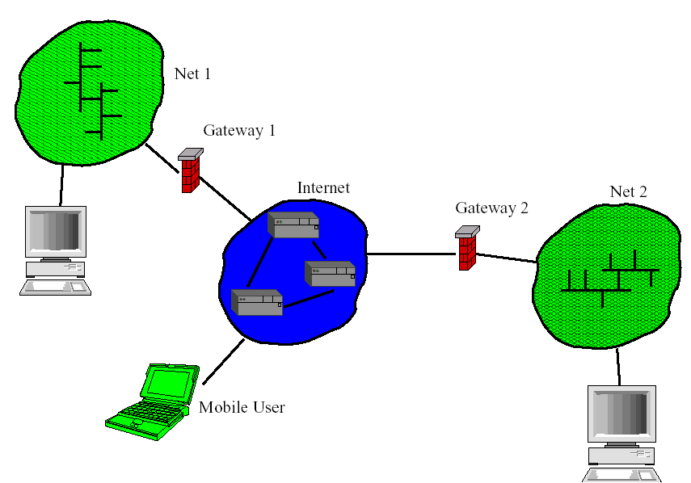
Mode of Use
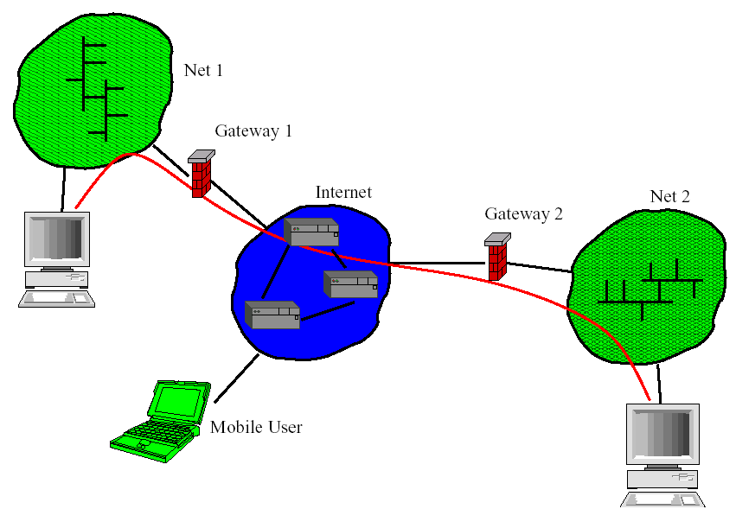
Modes of Use
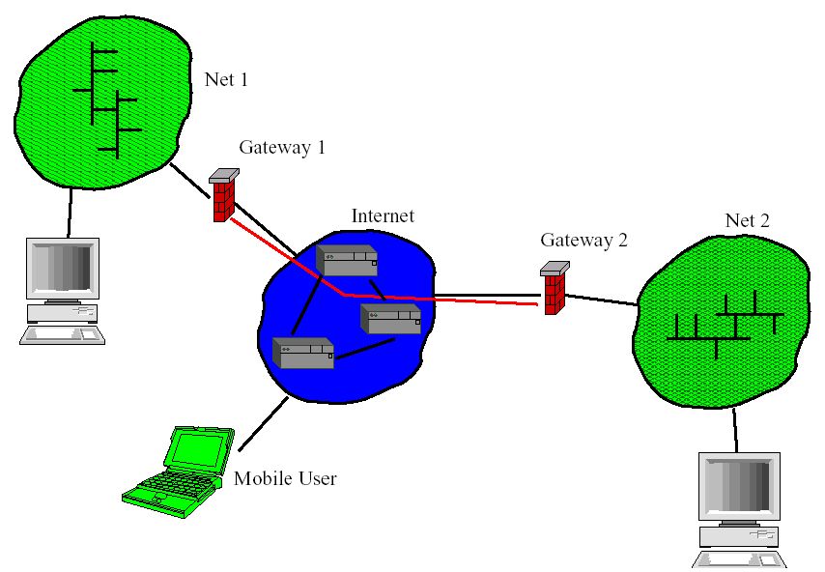
Modes of Use
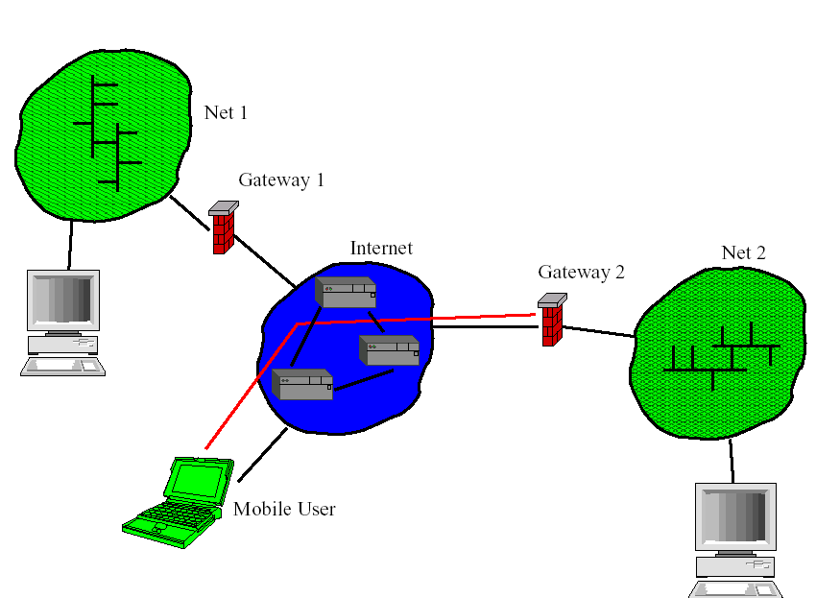
IPsec 30k ft. View
Wire protocols
Encapsulating Security Payload (ESP)
Authentication Header (AH)
Policy
Access control
Configuration
Key management
Manual
Automated (Photuris, IKE)

The Wire Protocols
Encapsulating Security Payload (ESP)
Confidentiality
Data integrity
Origin authentication (implicit)
Replay protection
Authentication Header
Data integrity
Origin authentication (explicit)
Replay protection
Header encapsulation

Wire Formats
ESP Header
IP Header
IP Header
IP Header AH Header
ESP Header
Payload
Payload
Payload
Trailer
Trailer
Payload
IP Header IP Header

Security Associations and Policy
Information relevant to an IPsec ``flow''
Cryptographic algorithms, keys
Security Policy Database (SPD)
Inbound/outbound policies
What to accept, reject, process with IPsec

Outbound Processing
Application or network
Data
IP Layer
IP

Outbound Processing
Encrypted and authenticated
Application or network
Network
IPsec Processing
IP IP
ESP Data
IP Layer

Inbound Processing
ESP Data
IP
IP Layer
Network IP

Inbound Processing
Application or network
IPsec Processing
IP Layer
Network
Data
IP

Key Management The Need
Manual/Static keying
Tedious
Requires significant human intervention
Prone to misconfiguration
Typically weak keys
Does not scale
Boring
Key establishment needs automation

Key Management Requirements
Negotiate SA parameters
Strong security
Principal authentication, keys
Dynamic rekeying
Minimal configuration

Key Management Requirements
Algorithm independence
Identity protection
Forward secrecy if needed
Efficiency
Scalable
Cure Cancer

That's easy!
Wellknown cryptosystems/protocols
DiffieHellman, RSA/DSA, 3DES/AES,
HMACSHA1, etc.
Mixin some engineering
Just put them all together...

ISAKMP
Framework for writing security protocols
Standardized payloads
Exchange types
Payload processing rules
Flexibility
Domain Of Interpretation concept

Internet Key Exchange (IKE)
Combination of ISAKMP and Oakley
Uses UDP (port 500)
Twophase protocol
Establish secure channel
Authenticate peers
Negotiate application parameters
Various authentication mechanisms
Various key agreement mechanisms
DiffieHellman
Kerberos (W2K)

IKE Main Mode Signatures
The payloads on the last two messages are encrypted
Header, Attributes
Header, Attributes
Header, Key Material, Initiator Nonce
Header, Key Material, Responder Nonce
Header, Initiator ID, [Certificate], Signature
Header, Responder ID, [Certificate], Signature
Initiator Responder

IKE Main Mode Passphrase
Header, Attributes
Header, Key Material, Initiator Nonce
Header, Initiator ID, Initiator Verification Hash
The payloads of the last two messages are encrypted
Header, Responder ID, Responder Verification Hash
Header, Key Material, Responder Nonce
Header, Attributes
Initiator Responder

IKE Aggressive Mode Signature
Header, Attributes, Key Material, Initiator Nonce, InitiatorID
Initiator Responder
Header, [Certificate], Signature
Responder ID, [Certificate], Signature
Header, Attributes, Key Material, Responder Nonce,

IKE Phase 2 Quick Mode
All payloads (except for the Headers) are encrypted.
Header, Hash(2), Attributes, Responder Nonce,
[Key Material], [Initiator User ID, Responder User ID]
Header, Hash(3)
Initiator
Header, Hash(1), Attributes, Initiator Nonce,
Responder
[Key Material], [Initiator User ID, Responder User ID]

Problems With IKE
Complicated
Feature bloat
Huge documentation
Interoperability problems
Denial of service problems
Bad cookies
Phase separation not as useful as expected

Threat Model
The usual attackers in the network...
DDoS script kiddies
Implementor
System administrator/user
Standards committees

New Requirements
Security
Forward Secrecy
Privacy
DoSresistance (memory, CPU)
Efficiency
Proof of security
Simplicity
Avoid negotiations/options
Some are tunable

JFKi Protocol
I>R: Ni, g^i
R>I: Ni, Nr, GRPINFO, IDr, g^r, Sig(g^r, GRPINFO),
HMAC{Hkr}(Nr, g^r, Ni, g^i, IPi)
I>R: Ni, Nr, g^i, g^r,
HMAC{Hkr}(Nr, g^r, Ni, g^i, IPi)
E{Ke}(IDi, sa, Sig(Ni, Nr, g^i, g^r, IDr, sa))
R>I: E{Ke}(Sig(Ni, Nr, g^i, g^r, IDr, sa, sa'), sa')

JFKr Protocol (LBJ)
I>R: Ni, g^i
R>I: Ni, Nr, GRPINFO, g^r,
HMAC{Hkr}(Nr, g^r, Ni, IPi)
I>R: Ni, Nr, g^i, g^r, HMAC{Hkr}(Nr, g^r, Ni, IPi),
C = E{Ke1}(IDi, sa, Sig(g^i, g^r, Ni, Nr, GRPINFO)),
HMAC{Ka}('I', C)
R>I: D = E{Ke2}(IDr, sa', Sig(g^i, g^r, Ni, Nr)),
HMAC{Ka}('R', D)

Important details
Ke and "application" keying material derived from
g^xy, Ni, Nr
Responder (and Initiator) can reuse g^x and g^y, key
material changes
Identity protection guarantees depend on the protocol

More details
Responder does not keep state on receiving Msg 1
HMAC is produced/verified by the Responder only
Can be something other than HMAC
HMAC is used to quickly discard DoS packets
Patricia trie, O(w) lookup
Reset when Hkr is changed
IP embedded in cookie

Proof of security
With PFS, security based on intractability
assumption of the DH problem
Without PFS, intractability of DH and the HMAC

JFKi
Based on proof of security for ISO 97983
A>B: A, Na, g^a
B>A: B, Nb, g^b, Sb[Na, Nb, g^a, g^b,A]
A>B: Sa[Na, Nb, g^a, g^b,B]

JFKr
Based on proof of security for IKE and SIGMA
Add cookie, reverse directions, encrypt messages
A>B: Na, g^a
B>A: B, Nb, g^b, Sb[Na, Nb, g^a, g^b], Hka(Na, Nb, B)
A>B: A, Sa[Na, Nb, g^a, g^b], HKa(Na, Nb, A)

